
Amazon Interview Worksheet
ARE RIGHT, A LOT
Definition and Indicators

Are Right, A Lot: Leaders are right a lot. They have strong judgment and good instincts. They seek diverse perspectives and work to disconfirm their beliefs.
What this looks like in Practice
As a people manager do you… | As an individual contributor do you…
- Use sound business judgment to make the right decisions quickly and achieve results, even in the absence of complete data?
- Question whether decisions are being made in the Company’s and customer’s best interest and change course when they are not?
- Actively seek out the best solutions, recognizing that great ideas often come from others? | - Recognize that your idea may not be as good as someone else’s and get on board with the best idea?

Are Right, A Lot - Suggested Behavioral Interview Questions
For each question you choose, use a separate STAR Worksheet
Questions for (Manager) in parentheses

- Tell me about a decision for which data and analysis weren’t sufficient to provide the right course and you had to rely on your judgment and instincts. Give me two to three examples. They don’t have to be big strategic decisions – could be big or small.
- Tell me about a time you made a difficult decision and how you knew it was the right solution (probe on how they evaluated the options, if they received input, what data they reviewed, etc.)
- Give me an example of when you have to make an important decision in the absence of good data because there just wasn’t any. What was the situation and how did you arrive at your decision? Did the decision turn out to be the correct one? Why or why not?
- Tell me about a time when your view on something important was significantly changed by someone that came from a different perspective? What was your reaction? What made you change your mind?
- Tell me about a time where you sought out perspectives other than your own to make a product/service/project better
- Tell me about a time when you made a bad decision and the learning from the experience enabled you to make a good decision later. What did you learn that you were able to apply?
- Tell me about a time when you have been faced with a challenge where the best way forward or strategy to adopt was not “clear cut” (i.e. there were a number of possible solutions). How did you decide the best way forward?
- Tell me about an error in judgment you made in the last year or two, what it was and the impact of it.
- Tell me about a business model decision or key technology decision or other important strategic decision you had to make for which there was not enough data or benchmarks. In the absence of all the data, what guided your choice and how did you make the call? (follow up with the alternatives considered and how/why they were ruled out in favor of the path taken, what was the risk mitigation strategy? Outcome? Ask for another example and potentially a third until you are sure this is a pattern and not a one off). (Manager)
- What are the top strategic issues you’ve had to face in your current role? What decisions did you end up making? (Manager)
STAR WORKSHEET

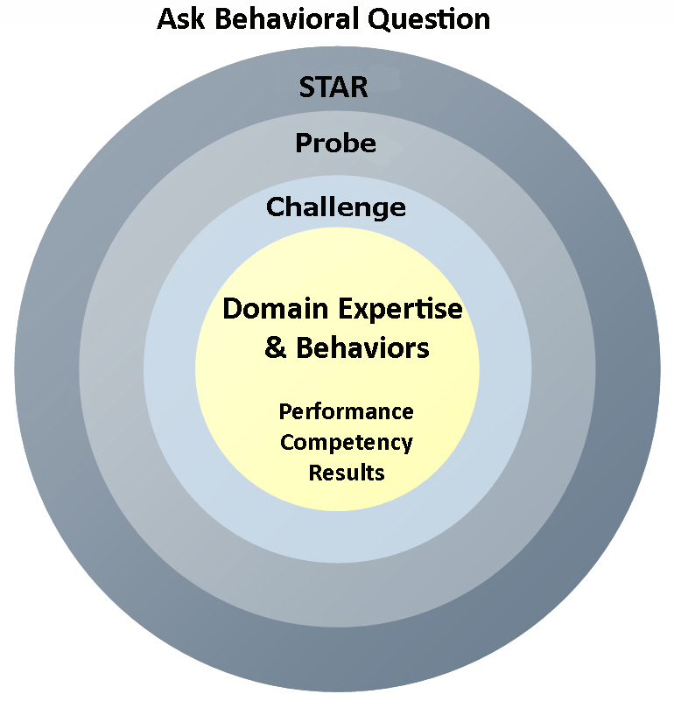
Your Behavioral Question:___________________________________________________________________Leadership Principle:_________________

- Choose behavioral question that provoke specific examples or stories for your assigned Leadership Principle(s).
- Process the example using STAR. Stories have beginnings (Situation/Task), middle (Actions) and ends (Results).
- Once you have established the story, PROBE to dive deeper on your assigned competency (Leadership Principle), get clarity or pursue a concern.
- If appropriate, CHALLENGE the candidate’s statements, decisions or thought process.
S  T | SITUATION/TASK - Describe the situation/task you faced and the context of the story  Answers the questions: where did this occur, when did it happen, why is it important?  Probing Questions:  - Why is this important? What was the goal?  - What was the initial scope of the project? What were the challenges?  - What were the risks and potential consequences if nothing happened?  Challenge Questions:  - Why did you choose this story to illustrate a xyz accomplishment?  - What other stories can you think of that demonstrate.. xyz?  - Could you come up with an example that is more recent? | Notes
A | ACTION - What actions did you take?  Answers the questions: what did you personally own, how did you do it, who else was involved?  Probing Questions:  - Deep probe functional expertise and/or assigned core competency.  - Were you the key driver or project owner?  - What was your biggest contribution? What unique value did you bring?  - What were the most significant obstacles you faced? How did you overcome them?  Challenge Questions:  - What did you do specifically versus the team?  - How did you set priorities…deal with xyz problem… or get manager buy-in?  - What decisions did you challenge? Why? How did you influence the right outcome?
R | RESULTS - How did you measure success for this project? What results did you achieve?  $ Cost savings, revenue generation  # Quantify to understand volume, size, scale  % Percentage change, year over year improvements  Time to market, implementation time, time savings  Impact on the customer, the team  δ Quality improvements  Probing Questions:  - Why did you choose to focus on these results? What other results were important?  - You mentioned revenue, what percentage change is that year over year?  - What trade-offs did you have to make to achieve this? (quality, cost, time)  - I’m concerned about… (the time it took, the volume, the customer impact), tell me more…  Challenge Questions:  - What were the lessons learned? What would you have done differently?  - How would you implement this at Amazon?  - How did these results compare to your actual goals? (refer back to goal stated in Situation)

